Name : Jeevan Koshy

Roll Number : 1740256

1. 5 cornered star =

xx:[0,3,0,3,4,5,8,5,8,4,0];

(xx)[0,3,0,3,4,5,8,5,8,4,0]

yy:[0,4,6,6,9,6,6,4,0,3,0];

(yy)[0,4,6,6,9,6,6,4,0,3,0]

wxplot2d([discrete,xx,yy]);

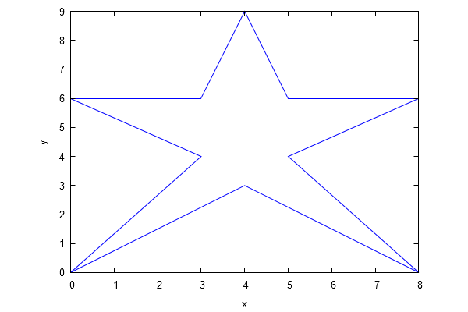

1. Tan x curve =

wxplot2d(tan(x),[x,-6,6],[y,-4,4]);

